https://www.metinfo.cn/download/

download url

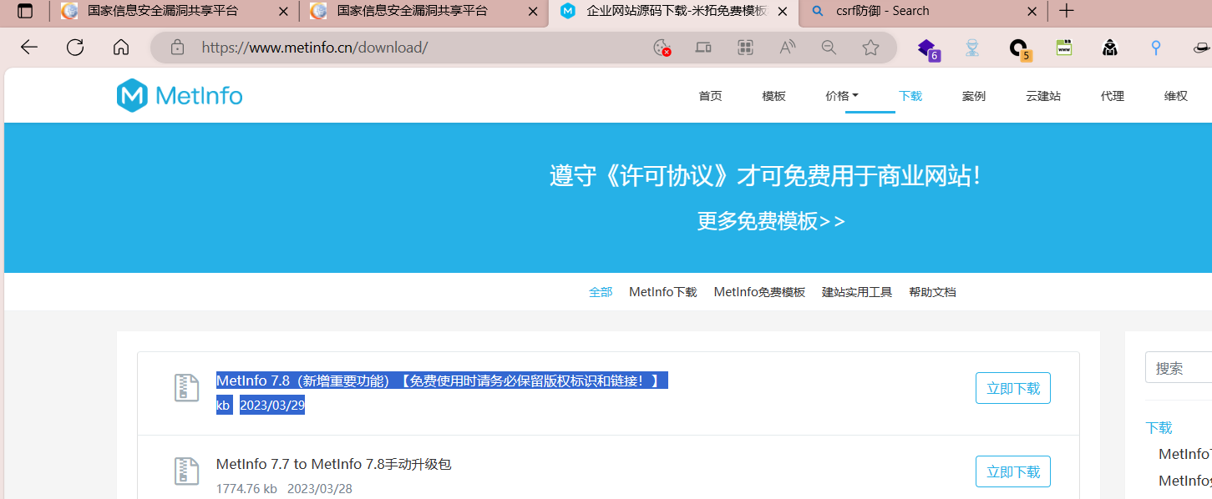

In MetInfo7.8 app system admin admin index. class. php, doSaveInfo() does not defend against csrf, but only determines whether it is occupied. CheckField() only checks if the user input is malformed, and the rest is verified to be empty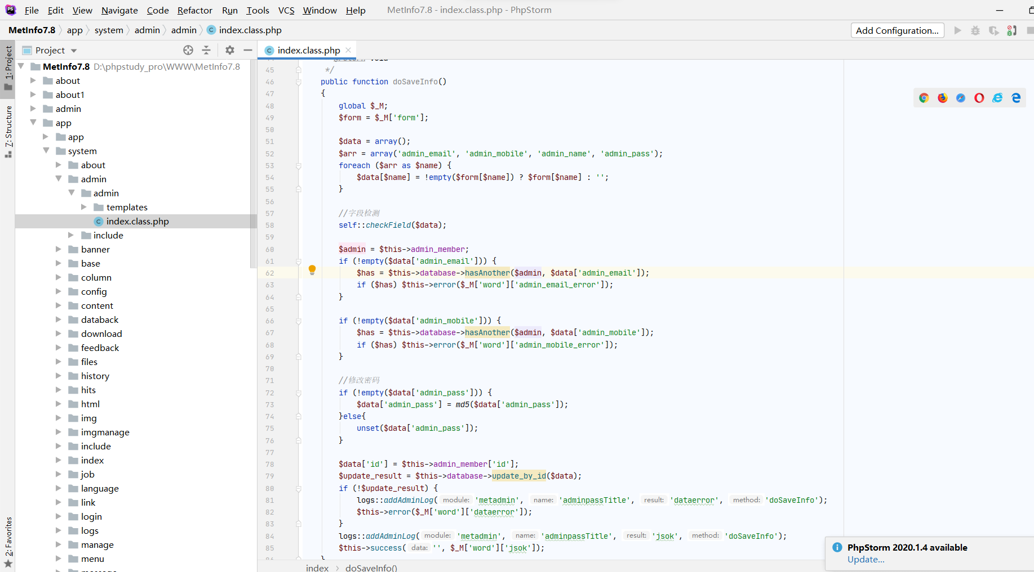

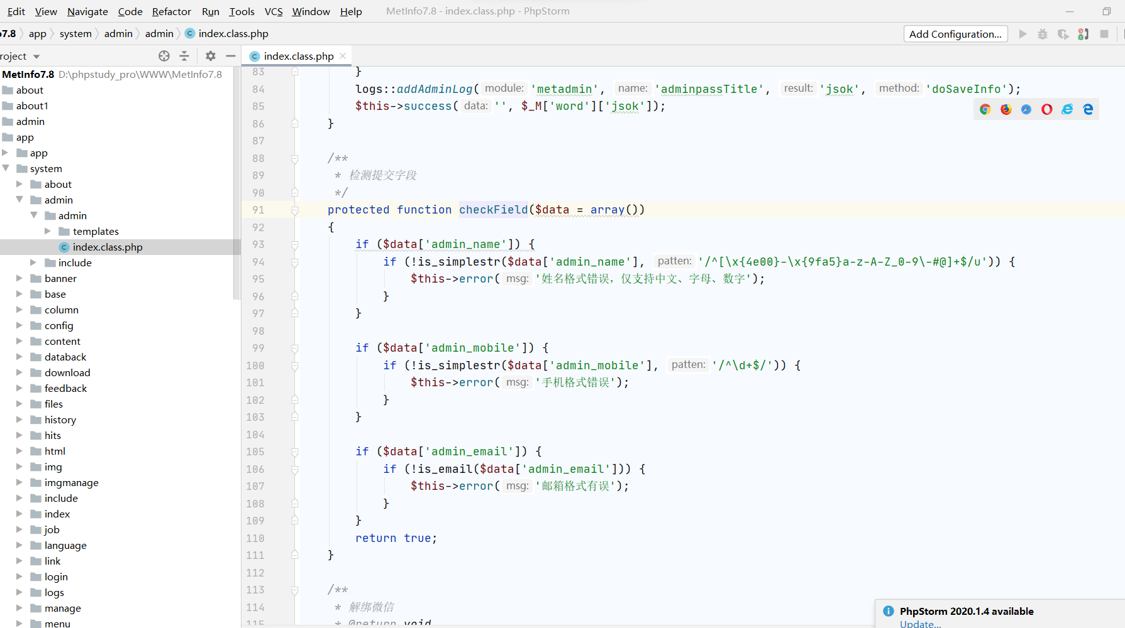

Click to modify the information. The login password and password are indeed the ones to be modified

I changed it to 123456789

Capture the package after saving and send it to BP CSRF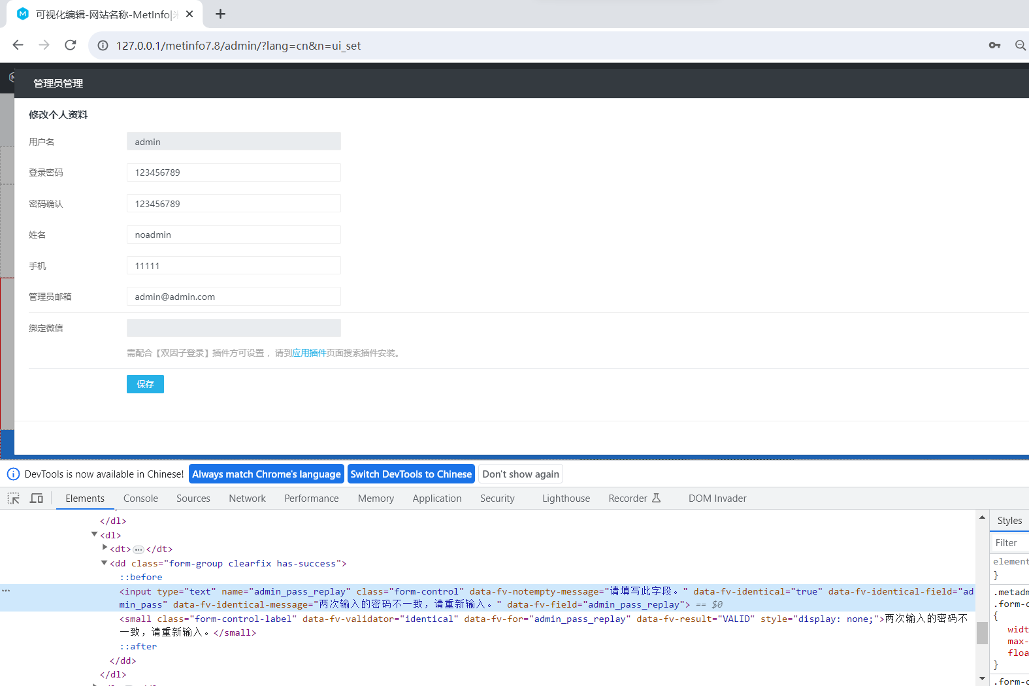

The current password has changed to 123456789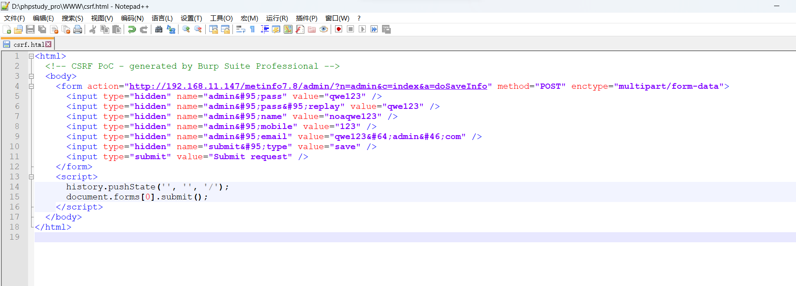

Change the password to qwe123, and choose the other information yourself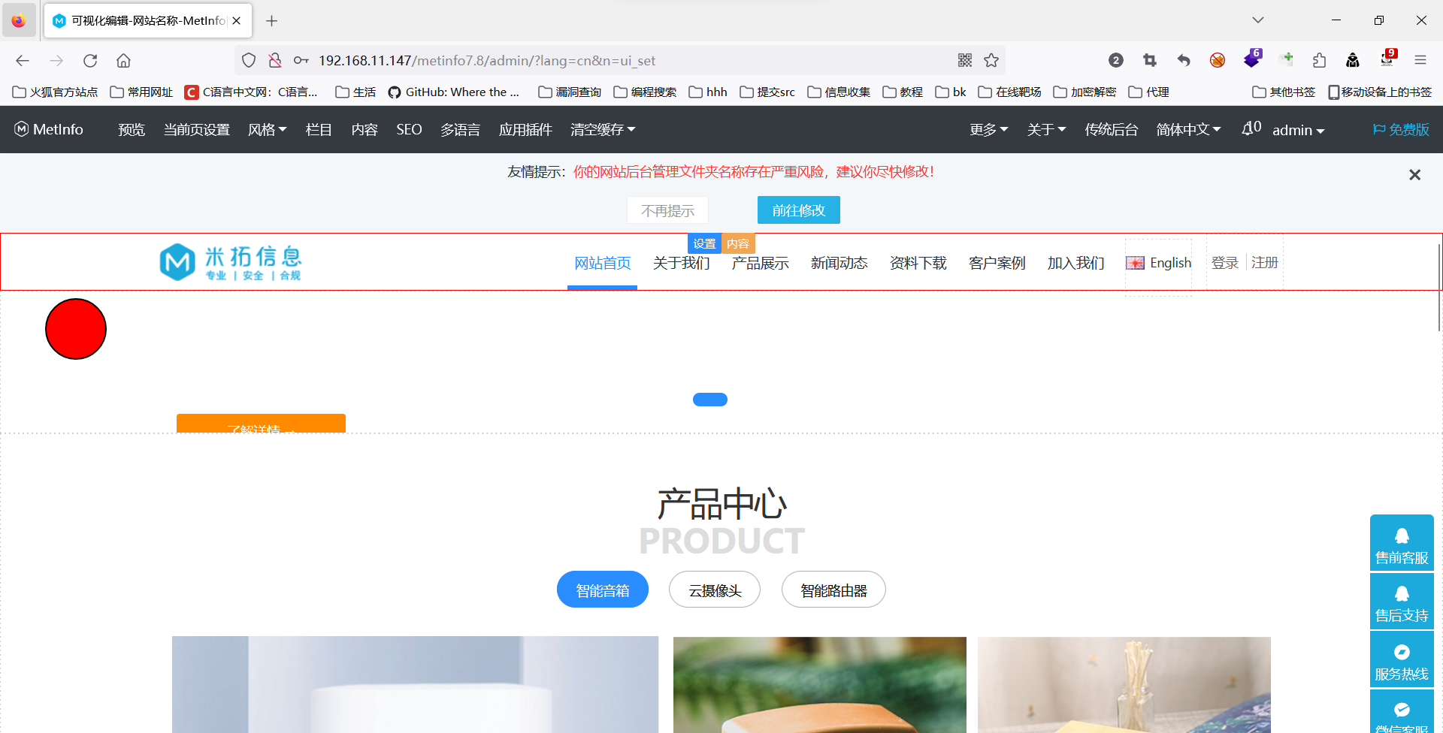

Switch to browser access <http://192.168.11.147/csrf.html>

Successfully returned, successfully modified the password and other information of the test1 account

